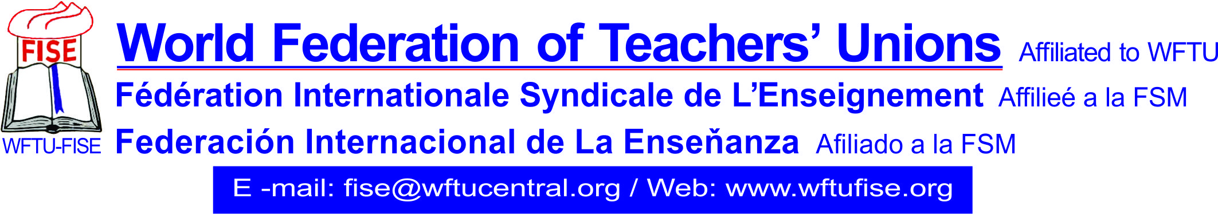

Athens, 08th November 2020
FISE: Solidarity statement with KTÖS
The World Federation of Teachers’ Union, FISE, member of WFTU, strongly condemns the threats and attacks against the Cyprus Turkish Teacher's Trade Union (KTÖS) and its General Secretary Şener Elcil.
We demand an immediate end to the unacceptable and condemnable efforts that aim to silence the trade union movement of teachers by intervening to internal affairs and the operation of the trade unions.
FISE, its affiliated members and the teachers around the world express their internationalist solidarity with the members and friends of KTÖS and demands the respect of the will of the Turkish Cypriot community.
We are standing by the workers and teachers in Cyprus and we are struggling for the defence of the right of association and the safeguarding of the uninfluenced representation of the workers with respect for the democratic processes and independence of their trade unions.
The Secretariat

