Comrades, friends, brothers and sisters

May Day greetings!

Today the working people face very serious attacks.

Using Covid-19 as an excuse, the employers and governments want to push us back to those days, 134 years ago, when the Chicago martyrs sacrificed their lives fighting for 8 hour work day. The BJP government at the centre is reportedly taking measures to legalise 12 hour working day. The BJP governments in Gujarat and Madhya Pradesh have already issued notifications to that effect.

The BJP government at the centre also wants to complete the labour law codification process by executive order or through the ordinance route to attack the basic rights of the working class to organise and to strike. The Gujarat Chamber of Commerce and Industry has demanded that trade unions should be prohibited for at least one year and to reduce the wages of the contract workers to the level of the MGNREGA workers, to Rs. 202 a day. The government and its masters, the big industrialists obviously want the workers to be pushed into slave like conditions. The order of the MHA, dated 19.04.2020,which prohibits movement of the migrant labour across state borders, but permits it across all the districts within the state they are locked-down in, is a gross violation of human rights. Many more attacks on the rights of the working people are on the anvil on the plea of reviving the slowing-down economy, further aggravated by Corona and lockdown.

Instead of mobilising financial resources from the super rich, the government is putting the entire burden on the workers and the common people. It has announced that the DA/DR rise for the central government employees and pensioners, approved by the Cabinet, will not be paid up to July 2021. Several state governments are unilaterally deducting wages without any consultation with the employees. Despite all the directives and guidelines from the government, thousands of enterprises, both private and public, and appallingly even the public sector undertakings are retrenching contract/casual workers and cutting down their wages.

The working class cannot accept such attacks on its livelihood and working conditions.

The government claims to be facing a financial crisis due to Covid-19. The fact is the government had emptied its coffers much earlier by tax concessions to the Corporates, sale of profit-making PSUs, non-recovery of NPAs in PSU banks etc. The government is arm-twisting its employees into contributing to PM CARES Fund one day salary every month for one year! But the workers are already bearing the triple whammy – of the already existing global crisis and economic slowdown, then the Covid-19 and then the unplanned and preparation less countrywide lockdown. Large sections of the workers and employees, including the front line health workers, are working almost 24 hours a day risking their lives to save the lives of others. Large number of workers including the migrant workers and unorganised sector workers are bearing the brunt of corona and the lockdown in the form of job-loss, loss of earnings, even loss of shelters along with their family members going hungry under the sky.

Instead of providing any relief to the workers, who create the wealth of our country, who are today forced to starve and have become homeless, the government is extending concessions and incentives to the big corporates and businesses.

It is possible to mobilise the necessary resources by imposing a nominal, very small wealth tax on the super rich.

Every year, top 1% usurp 73% of our GDP. Today the wealth of the top 1% of the rich in our country is more than 4 times of total wealth of the lowest 70% of our people. The combined total wealth of 63 Indian billionaires is higher than the total Union Budget of India for the fiscal year 2018-19 which was at Rs 24,42,200 crore. 953 billionaires’ families in our country have an average wealth of Rs 5278 crores. The BJP government abolished wealth tax in the Union Budget of 2016-17. A small wealth tax on these super rich will easily enable the government to meet the expenditure necessary to provide relief to the around 50 crore of the workers and other sections of the toiling people.

But the government is not ready to do this. Instead, it wants to take Covid-19 as an opportunity to push its already existing anti-people ‘reforms’ agenda so that its corporate masters can further increase their wealth by sucking the blood of the poor workers and toiling people.

It is shocking to see the foot soldiers of the party in power, use the corona pandemic to demonise the Muslim community as a whole, sowing seeds of communal hatred.At the same time voice of dissent and democracy and constitutional rights as a whole are facing an added assault in the wake of Corona Virus and in the name of enforcement of lockdown.

The working class cannot allow this.

On this May Day, the International Day of Solidarity of the Working Class, let us pledge to defeat these machinations of the BJP government and its corporate masters.

On this May Day, in the midst of lockdown situation, let us observe May Day by raising the flag of our respective organisations in every house of our members and workers, every workplace which is in operation in lockdown period, maintaining physical distancing and at the same time asserting social solidarity and unity.

Let us pledge to

Unite to fight the corona virus, to stay safe and protect our health

Unite to fight to defend the right of eight hour working day, which is under attack

Unite to fight against the merger of 44 labour laws into four courts only to favour employers curtailing the rights of workers

Unite to fight to defend the existing social security, occupational safety health measures and to make them inclusive for universal coverage.

Unite to fight against privatisation of Government and PSUs to the multinationals, like 100% FDI in Indian Railways, Defence Factories, Coal, Port & Dock, Air India, Banks, LIC, 76 PSUs etc.

Unite to fight the manoeuvres and machinations of the capitalists and the governments that represent them, to shift the burden of the economic crisis aggravated by the virus entirely on to the working class

Unite, to fight the dirty attempts of the capitalists and the governments that represent them, to pauperise the workers and denude them of their hard won rights while protecting profits and wealth of the big corporates, generated by the working class and the toiling people

Unite and fight to thwart all attempts to disrupt working class unity and unity of all toiling people and divide them on the basis of religion, region, race, caste, ethnicity and gender

Unite to fight and defeat the attacks of imperialism on the workers and people of the world to establish its hegemony and push the diktats of international finance.

Unite to fight heighten the struggle for the end of the exploitative capitalist system and usher in a new exploitation free society, a socialist society

Long Live May Day
Long Live Working Class Solidarity
Long Live Worker Peasant Alliance
Long Live Socialism
Down With Capitalism

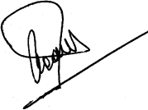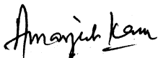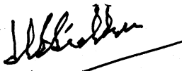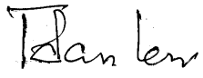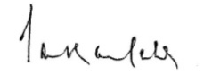
INTUC AITUC HMS CITU AIUTUC
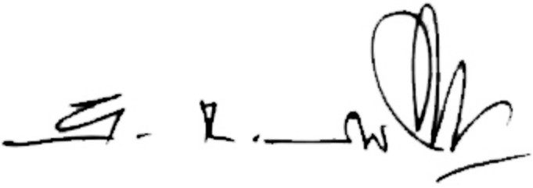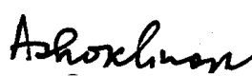
TUCC AICCTU LPF UTUC

